System Use Case Diagram

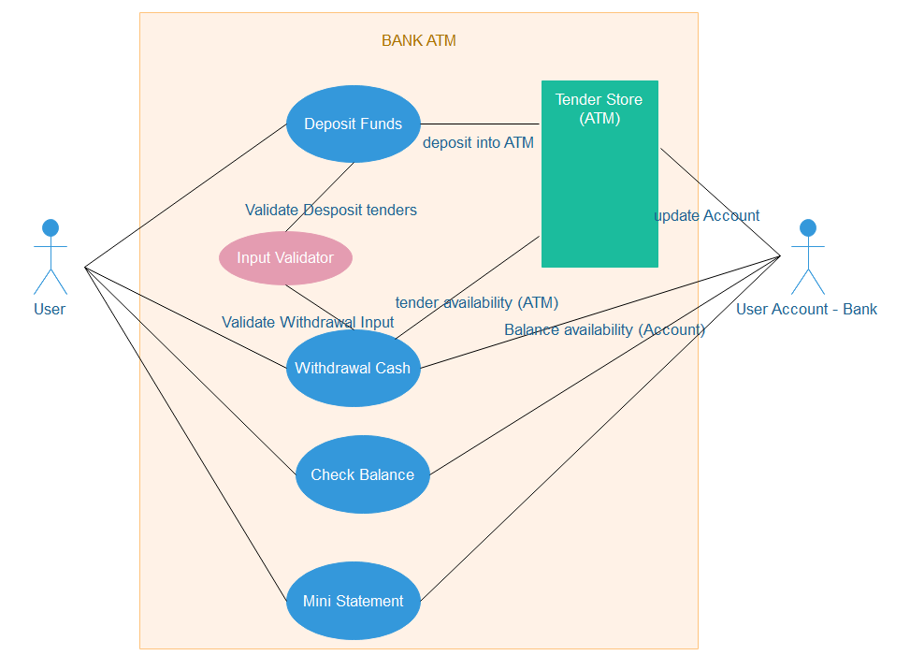

Withdrawal Flow Diagram – Chain of Responsibility Design Pattern

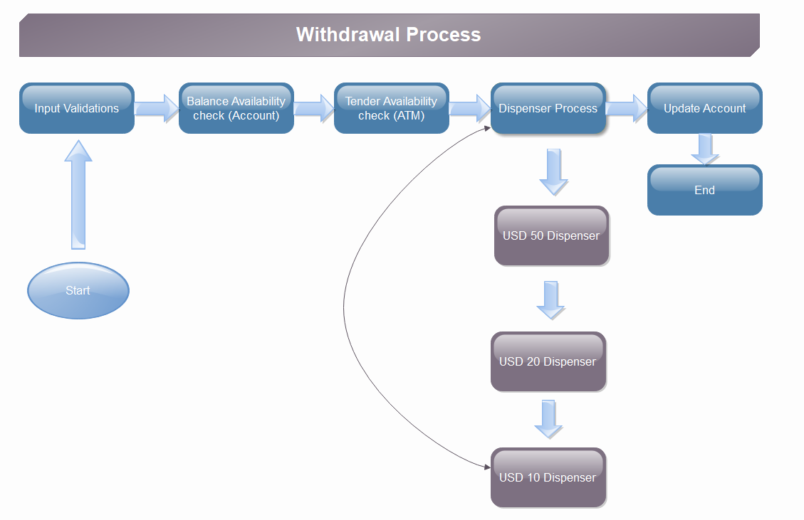

Readme

1. Standalone ATM Simulator Code developed using Java, Springboot 2.
2. AtmSimulatorApplication – Application boot class.
3. ATMOperationsExecutor – client controller class.
4. UserTransactionController – main service class handles processes.
5. TransactionValidator – input validator.
6. Execute Junit UserTransactionControllerTest for all positive & negative scenarios.
7. Validation scenarios handled:
   1. DepositInvalidDenominationException – deposit scenario.
   2. InsufficientFundException – withdraw scenario.
   3. WithdrawInvalidAmountException – withdraw scenario.